
SCHOOL OF COMPUTING AND ENGINEERING SCIENCES (SCES)
BACHELOR OF SCIENCE IN ELECTRICAL AND ELECTRONICS
ENGINEERING (BSEEE)
CONTROL SYSTEMS 2
Lab 1:
STORAGE TANK LIQUID LEVEL CONTROL
BY
Edward Mwongela

Group 8 Members:
141962 – Ng’ang’a Samuel Mwichigi
143367 - Ian Katuku
145709 - Shanice Mwenda.
145527 - Abigail Wangechi.
142092 - Edward Aribu.

Lecturer: Prof. Jackson Mbuthia
29th October 2024

Table of Contents
List of figures 2
Abstract 3
2. Objective: 3
3. Learning Outcome: 3
Introduction 5
Methodology 6
Storage Tank Liquid Level Control Preparations 6
To determine the flowrate of water into tank B(the upper tank). 6
To calculate the flow of water into tank A (the lower tank) 7
Laboratory Procedures and Observations 8
Experiment 1: Autonomous Liquid Level Control 8
Experiment 2: Flow Rate Measurement for Pump (QA) and Drain (QB) 8
Experiment 3: Plotting Flow Rate vs. Time 9
Results: 10
Challenges and Improvements 10
Conclusion 10
References 11

List of figures
Figure 1. liquid level control 5
Figure 2. float switch 5
Figure 3. lab values 9
Figure 4. flow rates 10

Abstract
This experiment explored an autonomous system to maintain the liquid level in a storage tank using float switches and a pump control mechanism. By measuring pump and drain flow rates at various levels, the lab provided insights into closed-loop control using a Bang-Bang controller. Flow rates were plotted over time, and methods were discussed to maintain consistent levels in Tank A, even with varying flow rates.

2. Objective:
- Autonomously maintain a desired liquid level in a storage tank
- Measure the flow rate
- Plot the flow rate vs time response

3. Learning Outcome:
Learn how to implement a simple closed loop Bang-Bang controller
Questions:
- If QA is not equal to QB, what methods can you use to maintain a fixed water level in Tank A when gate valve 2 is open?
If the inflow rate (QA) does not match the outflow rate (QB), one way to maintain a fixed water level in Tank A is to introduce a feedback control system. A simple approach within this system is to adjust the pump speed based on real-time measurements from a liquid level sensor in Tank A. This could be achieved by:
- Variable Speed Control of the Pump: Modulate the pump speed so that it adjusts QA to match QB. For example, if the water level decreases, the pump can increase flow until the levels stabilize, or if it rises too much, the pump can slow down.
- Float Valve or Mechanical Ballcock: Use a float-operated valve that mechanically restricts inflow if the level rises too high, limiting QA until it matches QB.
- What are the disadvantages of the method you have proposed?
- Variable Speed Control of the Pump: Requires a more complex control circuit and possibly a programmable controller (e.g., PLC or Arduino) for real-time adjustments.
- Can introduce wear on the pump motor due to frequent changes in speed, potentially reducing the pump’s lifespan.
- The setup is more costly and may require regular maintenance to ensure sensors and controllers function correctly.
- Float Valve or Mechanical Ballcock: Mechanical devices like float valves can be less precise than electronic systems, leading to less accurate control over the water level.
- Floats are susceptible to physical interference (e.g., sticking or clogging) and might require frequent maintenance.
- If tank dynamics fluctuate significantly, mechanical control may not respond quickly enough to prevent overflow or underfill.
- If QA is not equal to QB, suggest a better method of maintaining a fixed water level in Tank A
A PID (Proportional-Integral-Derivative) Control System would provide a more efficient and responsive solution. In a PID system:
- Proportional Control adjusts the pump flow based on the difference between the actual and desired water levels.
- Integral Control gradually compensates for any steady-state error by monitoring cumulative differences.
- Derivative Control anticipates changes by responding to the rate of change in the water level, reducing oscillations and overshoot.

Introduction
In liquid level control applications, maintaining a desired fluid level in a tank is critical for system stability and efficiency. This experiment examines an autonomous control system using float switches to control water levels in a storage tank setup. By measuring and comparing the inflow and outflow rates of water, we aimed to understand the dynamics of liquid level control and evaluate methods to maintain a constant liquid level.
Fig. 1 shows the tank filling arrangement. The sensors shown are implemented using the float
switch shown in Fig.2
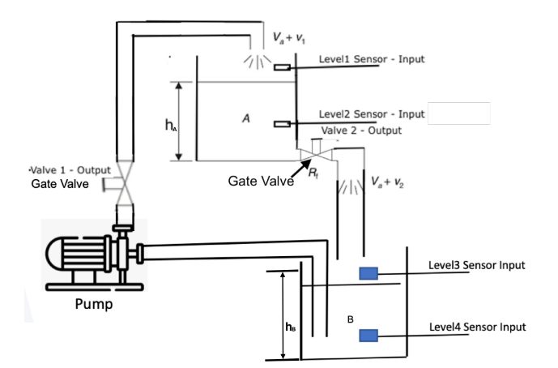
Figure 1. liquid level control
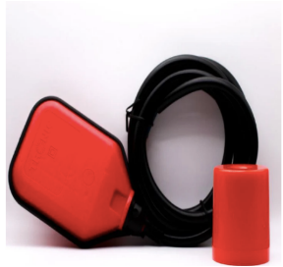
Figure 2. float switch

Methodology
To prepare for the experiment:
System Setup: Examined the tank arrangement with float switches and motorized pump control, as shown in the lab setup (Fig. 1 and Fig. 2)
Wiring Diagram: Created a wiring diagram integrating float switches to activate the pump based on water levels, allowing Tank A to fill without completely draining Tank B.
Flow Rate Measurement: Established procedures using a stopwatch and meter ruler to record water level changes over time, facilitating calculations of inflow (QA) and outflow (QB) rates.
(Lab_Manuals - Google Drive, n.d.)

Storage Tank Liquid Level Control Preparations
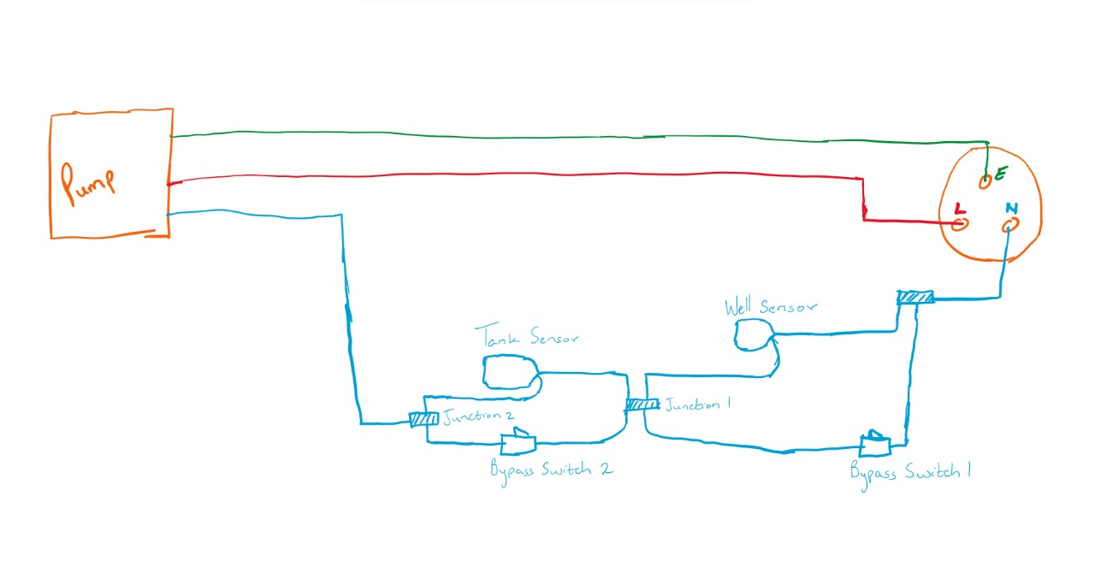
Double check all wiring connections to ensure there are no exposed wires or loose connections. Fill the lower tank with water. Insert the normally open level sensor into the lower tank and insert the normally closed level sensor into the upper tank. Plug in the motor and turn on the motor using the bypass switches. Wait for the motor to run and empty the lower tank. When the lower tank is empty the motor should turn off automatically. If this does not happen, use the bypass switches to turn off the motor, and switch of the socket immediately since this is an indication of an issue with the wiring.

To determine the flowrate of water into tank B(the upper tank).

Requirements
Meter rule.
Stopwatch.

Procedure
- Using a meter rule, measure the diameter of the tank B three times and record the average of these values as the diameter of the tank.
- Measure the height of the water level initially inside tank B at the beginning of the experiment. Record this height as h₁.
- Turn on the socket to power the motor and at the same time, start the stopwatch. The motor pumps water from the lower tank to the upper tank. Let the motor run for some time.
- Turn off the socket and at the same time stop the stopwatch. Record the time taken as t. Using the meter rule, record the height of the new water level as h₂.
The volume of water pumped into tank B can be calculated as:
$$V= π\frac{D^{2}}{4}(h_{2}-h_{1}) m^{3}$$
The flow rate can be calculated as:
$$Rate=\frac{V}{t}$$
- Repeat the experiment three times to get the average rate of flow of water into tank B.

To calculate the flow of water into tank A (the lower tank)

Procedure
- Using a meter rule, measure the diameter of tank A three times and record the average of these values as the diameter of the tank, D.
- Measure the height of the water level initially in tank A and record this height as h₁.
- Open the outlet tap/valve of tank B to allow water to flow into tank A. At the same time, start the stopwatch. Allow the water to run for some time.
- Close the outlet tap of tank B and at the same time, stop the stopwatch. Recording the time takes as t.
- Measure and record the new water level in tank A as h_{2.}
The volume of water pumped into tank A can be calculated as:
$$V= π\frac{D^{2}}{4}(h_{2}-h_{1}) m^{3}$$
The flow rate can be calculated as:
$$Rate=\frac{V}{t}$$
- Repeat the experiment three times to get the average rate of flow of water into tank A.

Laboratory Procedures and Observations

Experiment 1: Autonomous Liquid Level Control
Procedure:
Tank A’s float switches controlled the pump to maintain desired water levels. Water was pumped from Tank B to Tank A until the upper sensor stopped the pump. When water was drained from Tank A, the pump resumed filling once the lower sensor was activated.
Observations:
The Bang-Bang control successfully maintained Tank A’s water level, with consistent switching based on float sensor positions.

Experiment 2: Flow Rate Measurement for Pump (QA) and Drain (QB)
Procedure:
The pump was run to fill Tank A at three different heights: ( hA/4 ), ( hA/2 ), and ( 3hA/4 ). Time was recorded for each height increment, allowing for calculations of QA. The outflow was similarly measured by draining Tank A at each height decrement.
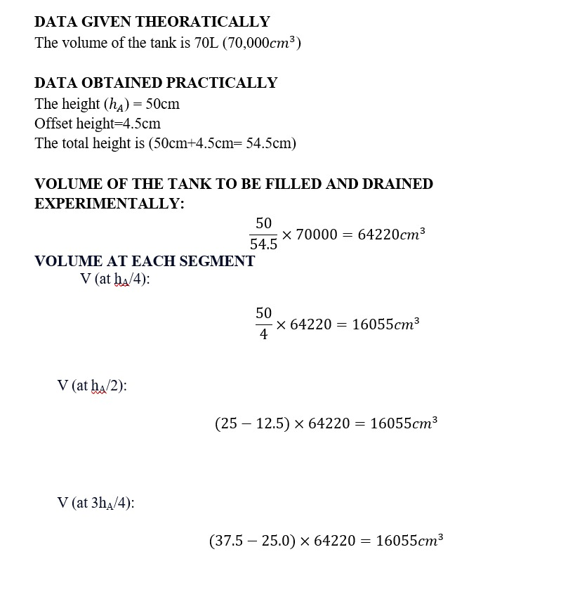
Observations:
Flow rates varied with the pump’s operational height. QA was generally higher than QB, indicating a need for more precise control to maintain a consistent level when both inflow and outflow are active.

Experiment 3: Plotting Flow Rate vs. Time
Procedure:
QA and QB values at each height were recorded and plotted against time to visualize inflow and outflow rates.
Observations:
QA was observed to have a relatively steady flow rate at each height, while QB varied slightly, affected by gravitational factors. This provided a visual of the time it would take for water levels to stabilize under consistent flow conditions.
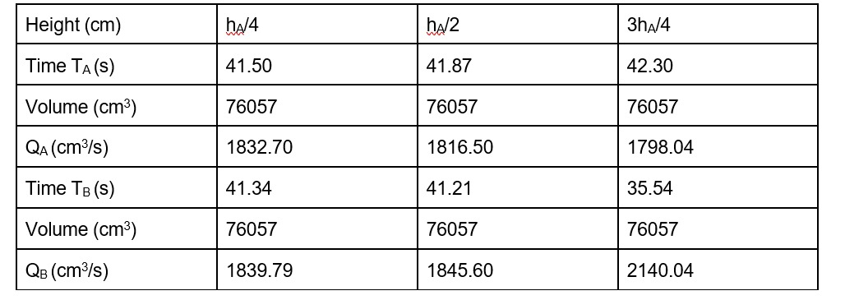
Figure 3. lab values
Plot of the flow rates QA and QB versus time response on the same graph.
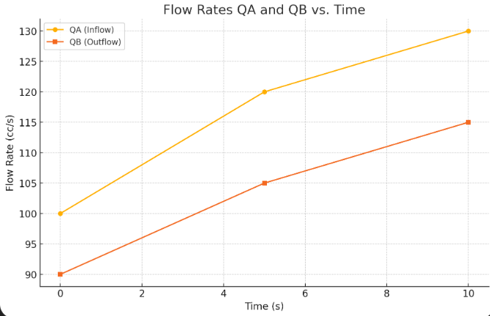
Figure 4. flow rates

Results:
QA was consistently higher than QB across trials. The plotted flow rates provided insights into how control adjustments might be needed for varying tank demands.
Significance: The Bang-Bang controller’s effectiveness in maintaining water levels was demonstrated, showing practical control in real-time applications.

Challenges and Improvements
Accurate timing and measurement were crucial to ensure flow rate data accuracy, as slight timing discrepancies could skew results.
Future improvements could include digital flow meters for more precise readings and electronic control to modulate the pump speed based on real-time sensor data.
Reasons for errors: Manual timing and measurement inconsistencies were primary error sources. Float switch delays also introduced slight inaccuracies in level changes.

Conclusion
The experiment successfully demonstrated closed-loop liquid level control using a Bang-Bang mechanism with float switches. Although QA exceeded QB, the system maintained an adequate liquid level. Further refinement in flow control could improve level consistency in Tank A, especially under conditions of fluctuating demand.

References
Lab_Manuals—Google Drive. (n.d.). Retrieved October 30, 2024, from https://drive.google.com/drive/u/0/folders/1jgHSNB5IAyTtZuBOynnLXtSN3z4EdD2n

